DESIGN AND CONSTRUCTION OF A DOOR SECURRITY ALARM SYSTEM BASED ON SMS VERIFICATION AND VOICE RECOGNITION

A.S. Falohun^{1*}
¹Department of Computer Engineering,
Ladoke Akintola University of Technology, Ogbomoso, Nigeria
*asfalohun@lautech .edu.ng

T. H. Akin-Olayemi²
Department of Computer Science,
Federal Polytechnic, Ado-Ekiti
²teeking2001@yahoo.com

B.O. Makinde³
Department of Computer Science
Osun State College of Technology, Esa-Oke
³bukolamakinde22@gmail.com

W. F. Akinleye⁴
⁴Department of Computer Science
Igbajo Polytechnic, Igbajo
Osun State.

O.P. Kehinde⁵ and T. M. Oyelami⁵
⁵ Department of Computer Engineering,
Ladoke Akintola University of Technology,
Ogbomoso, Nigeria

Abstract: Home security is very crucial, different ways of security system have been enhanced such as the use of alarms, monitoring system, through the interaction of electronic hardware, software and much more. This project involves SMS verification and voice message based door access system to detect intruders, trespassers, criminals or any form of criminal act. The project is to design and construct a door security alarm system based on SMS verification and voice recognition. The objectives of this project are as follows: To design a security system that would automatically control the operations of a door via voice command through android application development and via SMS verification using GSM module. To develop and implement a system that utilizes voice command and SMS verification technology for access. To provide perfect security for door access, this project made use of two different technologies viz SMS verification and voice recognition. The microcontroller continuously receives command from the GSM module and the android application which is connected through the Bluetooth module. It then takes decision on the basis of the command received. The system has been designed to work with GSM technology, which will generate a message, every time an intruder tries to get an unauthorized access to the house. There is a unique voice keyword that grants access to the door via Google’s open-source speech-to-text on the android application using HC-05 Bluetooth module is employed to serve as a wireless link between the android application and the door. Having designed the system and found it working properly according to its design, the aim of the project can be said to be achieved. Thus, Voice Recognition and SMS verification offers a better security than traditional methods of security.

Keywords: Security, GSM Module, Voice recognition module, Microcontroller, Access control system, Arduino

- INTRODUCTION
A security system is defined as a mechanism to detect intrusion, unauthorized entry into a building or a protected area and deny such unauthorized access to protect personnel and property from damage or harm. Security systems are mainly used in residential, commercial, industrial and military properties for protection against burglary (theft) or property damage, as well as personal protection against intruders.[22]
Nowadays, home security is very crucial. Different ways of security system have been enhanced such as the use of alarms, monitoring system, through the interaction of electronic hardware, software and much more. Recently, the rate of crimes involving robbery in hostels and houses is increasing. There is need to enhance home security systems to make them more sophisticated, effective in order to keep up with the increasing crime rate. Home security is significant for every home owner either in an individual house or an apartment.[22] Wireless security system can be used to provide security system for residential, industrial and for all domestic and commercial purposes, Security is an important factor today, as Technology develops day by day in the world likewise The crime gang also improves its technology to perform its operations. As a result of this, the technology of security should be modern with time to protect individuals from crime works. Due to the need to increase the security of life and properties in our environment, security systems are used as selective systems to decide who has access to a given location based on a personal distinctive traits of the user. It also serves the function of sensing or detecting false intrusion (using input sensory devices and gives early warning using audio warning devices alarm – light indicators and remotely controlled computer systems). The term false intrusion is used to mean any form of attempt to gain entry without following the proper pre-designed protocol(s) [7].
From time past till present, there are some earlier development like; security locks devices made of forged metal i.e. simple lock and bolt, the door chain, pin tumbler lock, the jam lock and padlock etc. Other recently developed security devices are gadgets like laser beam detectors, motion detectors, magnetic card readers. Most recent of these devices are offshoots of biometric engineering. They include voice recognition systems, finger print readers, retina eye scanners etc. The major characteristic of security devices is to prevent an intruder from gaining access to a location [26]. In recent years, home security has shifted away from simple control panels and deadbolt locks into cool, coveted high-tech gadgets. There are so many new things that have been invented when it comes to providing security. To understand how home security evolved into what it is today, It is necessary to take a look back at the past [23].
When World War I ended, an increase in crime followed. As a result, People became sensitive to security needs and were eager to find ways to protect themselves and their property. Additionally, many insurance companies began offering premium discounts to alarm subscribers. These events produced a consumer demand for alarm systems. During this time, homeowners may have subscribed to a service called door shakers— a group of night watchmen who would shake subscribers’ doors each night to ensure they were locked. More advanced users may have installed an alarm system that used electromagnetic contacts fastened to doors and windows, which were connected to a battery and bell. These systems were monitored by a central station that sent a guard to the residence when the alarm was triggered. Fast forward to today, homeowners have traded door shakers for automated, sophisticated systems. Now, to ensure that doors are locked and the alarm is set, users simply log in remotely via a web-enabled device and check the status of their homes. They can lock doors, arm the system, or adjust the thermostat with the touch of a button [32].
Video surveillance technology was developed in the 1940s; it wasn’t until the 1970s that it was used in homes as a security measure. An early model of an advanced video home security system included a large motorized camera that moved down a track to view the exterior of the home through four peepholes mounted in the front door [3]. The video camera transmitted grainy images of visitors to a stationary television monitor that also served as the control panel where the homeowner could remotely control the camera’s movements [32]. The panel, which was located in a separate room away from the camera, was equipped with security features such as an intercom to communicate with visitors, a door lock switch and an alarm button that could activate the alarm at the central station that monitors the residence [3]. Now, surveillance cameras are as small as one square inch, connected to the Internet and outfitted with powerful lenses that can capture and stream high definition video online that can be viewed from anywhere in the world [20]. Additionally, with a connected smart home, homeowners can program their security systems to send a live video clip of an area if motion is detected when the home is unoccupied and the alarm is activated [18]
Since last 4-5 decades, the concept of home automation has been there. People’s expectations regarding home automation and security have changed during the course of time due to the advancement of technology and services. Different security systems over the time tried to provide efficient convenient and safe way for home inhabitants to access their homes. Irrespective of the change in user expectations, advancement of technology, or change of time, the role of a home automation system has remained the same [22]. The tasks of a modern security system include identifying an intruder trying to gain access to the home, alerting the homeowner about the intrusion or intrusion attempt, preventing the intruder from gaining access to the home, and gathering or collecting evidence regarding the intrusion so that the perpetuators can be brought to justice [32].

- Overview of Security Alarm System
A security alarm is a system designed to detect intrusion – unauthorized entry – into a building or other area such as a home or school. Some alarm systems serve a single purpose of burglary protection; combination systems provide both fire and intrusion protection [18]. Alarm systems serve a single purpose of burglary protection; combination systems provide both fire and intrusion protection. Intrusion alarm systems may also be combined with closed-circuit television surveillance (CCTV) systems to automatically record the activities of intruders, and may interface to access control systems for electrically locked doors [28]. Systems range from small, self-contained noisemakers, to complicated, multirally systems with computer monitoring and control. It may even include two-way voice which allows communication between the panel and Monitoring station [18].
There are different types of Home Security Alarm system. They are:
- Electric Current Alarm System
Electric current systems are the most basic monitoring tool, in that they only monitor entry points like doors and windows, and are often installed when a home is being built. With these systems, a low-voltage electrical circuit flows between two points.[51]
- Wired Alarm System
A hardwired alarm system describes a number of sensors throughout the home that are connected to a control panel, via a network of wires that run inside the walls and under the floors [51].
- Wireless Alarm System
Wireless security systems are the next generation of security equipment. They offer comprehensive protection, lower installation costs, and easy upgrades. Essentially, a wireless security system is comprised of alarms, sensors, cameras, and various detectors all connected to a main control panel via radio signals [51].
- Unmonitored Alarm System
Unmonitored (or self-monitored) security systems consist of equipment you can have a professional install or install yourself. Equipment can vary greatly between systems, but typical items include a control panel, motion sensors, door and window sensors, glass-break sensors, smoke detectors, and sirens [51].
- Monitored Alarm System
Monitored security systems are systems that are actively monitored by a professional home security company. When the system detects a break-in, fire, or other emergency, it notifies the security team and, in some cases, emergency responders [51].

Door Security Alarm System
Door alarms serve to create safe homes and offices by warning against intrusion at access points that get opened often. At the moment a door is opened by a burglary attempt, the sensors can activate a flashlight, a loud siren and a phone call, or any combination of the above.
A door security alarm system determines access and non-access to door; door security in the past was done through keys and locks. When a door is locked only someone with a key can enter through the door depending on how the lock is set up. Mechanical locks and keys do not limit the key holder to specific times or dates as long as the owner has access to the keys [30].
Mechanical locks and keys have their limitations; the keys can be easily copied or transferred to an unauthorized person. When a mechanical key is lost, the locks must be changed or replaced [35].
Electronic door security system solve the limitations to mechanical locks, a lot of methods can be used to replace the mechanical keys[33]. The method used and employed is SMS verification and Voice Recognition using text message and android app, access is granted using an assigned keyword from a registered number and a distinct voice keyword from the android app [30].
When access is granted, the door is unlocked for a set time, then locks after a time interval, once an individual uses a wrong keyword, an intruder SMS is sent to the phones of the house owners.

History of door security alarm system
- Locks and Keys
Mechanical locks (that is a device that keeps a door locked) began in Ancient Egypt more than 6 thousand years ago with the most primitive key device and lock being discovered in the capital of ancient Assyria, Nineveh ruins. This is the earliest form of door security alarm system that was used in office buildings, homes, etc., to keep belongings and information safe. In no time it proved to be insecure because thieves could break in, keys were stolen and intruders had unauthorized access to important things[53].


Figure 1: Ancient key [53]
- Keypads
One of the earliest security door alarm system was keypads. Keypads allowed employees and other authorized users to enter a personal identification number (PIN) or password that matched data in an electronic device. The system provided minimal security, but it was more efficient than locks and keys. It was a revolutionary idea at the time, but it was fundamentally flawed as anyone obtained the code, perhaps by looking over someone’s shoulder could then enter. Forgetting an assigned PIN or sharing it with others limited the effectiveness of the system. This was classed as a non-intelligent reader [52][.
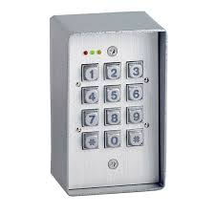
Figure 2: A door keypad [53]

- Card Readers
Recognizing the shortcomings of keypads, manufacturers developed card readers. Usually, a magnetic strip would be attached to the card which a staff member could then swipe through a narrow slot in order to gain access. Cards have become more sophisticated over time, with barcode, proximity, smart card and biometric readers offering different pros and cons for various commercial applications.
[52]
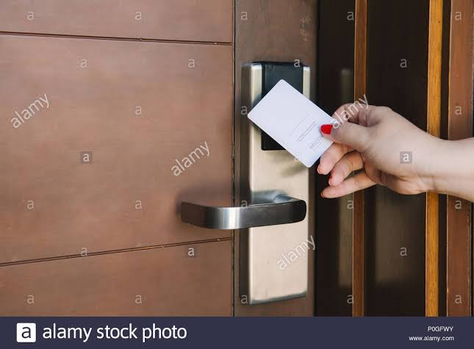

Figure 3: Card reader [53]
- Biometric readers
These special biometric readers are designed to read biometric information instead of a card that is carried. This makes use of fingerprint, facial, finger vein, voice recognition, iris recognition and others that is a much more secure system and costs more [55].

SMS (Short Message Service) System
SMS (Short Message Service) is a text messaging service component of most telephone, internet, and mobile device systems. It uses standardized communication protocols that let mobile devices exchange short text messages. An intermediary service can facilitate a text-to-voice conversion to be sent to landlines. SMS as used on modern devices, originated from radio telegraphy in radio memo pagers that used standardized phone protocols. These were defined in 1985 as part of the Global System for Mobile Communications (GSM) series of standards.
The first test SMS message was sent on December 3,1992, when Neil Papwort, a test engineer for Sema Group, used a personal computer to send “Merry Christmas” to phone of colleague Richard Jarvis. SMS rolled out commercially on many cellular networks that decade and became hugely popular worldwide as a method of text communication. By the end of 2010, SMS was the most widely used data application, with an estimated 3.5 billion active users, or about 80% of all mobile phone subscribers.
The service allows users to send and receive messages of up to 160 characters (entirely alpha-numeric) to and from GSM mobiles. Although most SMS messages are sent from one mobile phone to another, support for service has expanded to include other mobile technologies such as ANSI CDMA networks and Digital AMPS. Mobile marketing, a type of direct marketing, uses SMS [54].

Figure 4: SMS on a mobile phone [50]

- SMS Control
GSM being one of the most popular and used means of mobile communication makes it to be viable and unique. To perform the task, The GSM modem must support an “extended AT command set” for sending/receiving SMS messages. The GSM modem (SIM800L) used for this work was configured using standard AT commands that can carry out operations of conventional phone. [44] The major usefulness of this module is its ability to interface with other circuit elements like the microprocessor; hence making it possible to embed it with other systems.
- GSM Module (SIM800L)
GSM (Global System for Mobile Communication) is a wireless network system that uses a mobile operator and functions just like a mobile phone. The GSM module has a SIM card slot, thus making the module have a mobile number of its own and enabling it to activate communication over the network. The user can send or receive an SMS as well as make or receive voice calls over the module interface. The GSM module can be connected through the serial port or to a microcontroller. There are a set of AT commands that are used to establish communication between the microcontroller and the GSM module. The GSM module used in this security system uses SIM800L module [37].
SIM800L is a miniature GSM modem, which allows for GPRS transmission, sending or receiving SMS, as well as making or receiving phone calls. Its low cost, small footprint and quad brand frequency support make it to be a perfect solution for any project that requires long range connectivity. SIM800L has two antennas. It consumes about 300mA in idle mode and about 2A in busy mode. It needs between 3.8V to 4.2V, in which 4V is recommended in most cases. It uses UART (serial) means of communication.
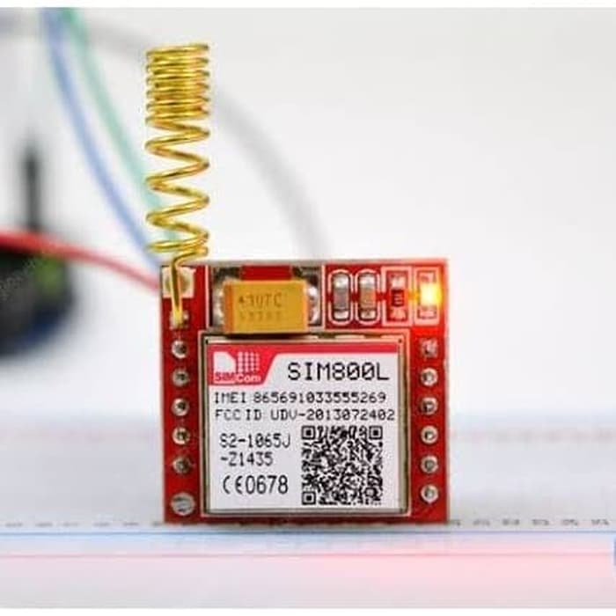
Figure 5: GSM Module (SIM800L) [61]

- SMS Implementation
The SIM800L module acts as the mediator between the microcontroller unit and the mobile phone and it is also responsible for the communication between them. The GSM module communicates with the microcontroller in a serial manner. It has an Rx and Tx pins on the board. These pins are connected to the Tx and Rx pins of the Arduino [44].
This unit is responsible for sending command from the microcontroller to the mobile phone and vice versa. The command sent by the user from the mobile phone is executed by the microcontroller. It does not require any special feature or application for the mobile phone to be a part of the system. The command to the microcontroller is sent through text messages from the mobile phone and the alert from the microcontroller is received as a text as well. Table 3.1 shows the AT commands used in the system [29].

- Advantages of Short Message Service (SMS) System
- Message can be sent at any time, day or night.
- Less time is needed to communicate hence, it is the fastest way to reach anyone.
- Anyone can send a message to the recipient even if he/she is available or not.
- Good for informal messages.

Limitations of Short Message Service (SMS) System
- There is no guarantee that the text message will be delivered to its destination.
- The delivery can happen very late due to congestion or the delivery may fail due to destination mobile is busy or out of service
- The SMS size is limited to about 160 characters.

Voice Recognition
An Android application (voice recognition on Android) was used for the voice recognition stage of this design. There are several platforms for developing smartphone applications such as Windows Mobile, Symbian, iOS and Android. The Android platform is an open-source whereby users can easily customize the tools and develop applications according to their needs [18].
The Android SDK (Software Development Kit) provides a wide range of useful libraries, tools necessary to develop applications on the Android platform using the Java programming language. Any sound could be trained as voice command. Users need to train the application on android first before letting it recognize any voice command.
The interest in voice recognition is continually growing nowadays. Today, we distinguish two types of voice recognition;
Text-Dependent: depends on the specific sets of words the person says- you need step-up authentication and identity verification and in order to be activated, the user has to say the necessary phrase.
Text-Independent: does not depend on a specific text yet relies on conversation speech. The authentication does not require for the user to say a set of required phrases [34].

Wireless Link (Bluetooth)
HC-05 Bluetooth module is an easy to use Bluetooth SPP (Serial Port Protocol) module, which means it communicates with the Arduino via the Serial Communication. It uses a UART (serial) communication protocol which makes it easy to interface with any microcontroller or system. The HC-05 Bluetooth module is much different from all other Bluetooth devices because of its multiple pins and their functions. This module operates with TX and RX pins at 9600 baud rates. It offers two ways communication for shorter distances with fast speed [38].
HC-05 Bluetooth module has an enable pin which allows toggling between the command and data mode. Its range is up to 8 – 10 meters and it uses 5V to power up. It acts a slave only, that is, it cannot initiate communication. Figure 3.1 shows the Bluetooth module

Technical Specifications
Operating Voltage: 4V to 6V (Typically +5V)
Operating Current: 30mA
Range: up to 10meters
Communication Mode: Serial communication (UART)
Supported baud rate: 9600, 19200, 38400, 57600, 115200, 230400, and 460800.

Advantages of voice recognition via Bluetooth
- Generate personalization, personal conversations can be accomplished by voice.
- Talking is better than typing, life is easier and more efficient as voice inputs than typing.
- Voice recognition is a great option for people with motoric disabilities or difficulties to communicate much easier.
- Enables you to perform task or job more easily.

Limitations of voice recognition via Bluetooth
- Voice recognition remains useful for security system, however has certain limitations;
- Voice recognition via Bluetooth only work up to a range of 10meters because the maximum range for a Bluetooth connection is 10meters.
- Bluetooth connection has a limited connection of one phone at a time; it can’t connect two phones at same time to grant access to the door.

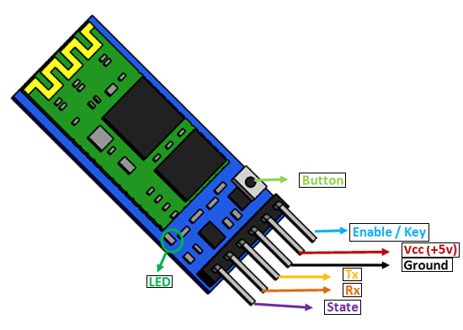
Figure 6: Bluetooth Module (HC-05) [60]

RELATED WORKS
Over the years, security system is implemented in various places. A security measure plays an important role in daily life. Some of the researchers have conducted and successfully developed various types of security systems using different technologies. There were several researchers on intelligent lock system depending on the number of security features which entails. In this section, some of the authors along with the Concept and theory of their works will be highlighted. The advantages, disadvantage and possible improvement (research gap) were enumerated.
[12] designed a digital door lock security system using the RFID technology. After receiving the tag information, the reader sends this information to the database for confirmation. If it holds, the information is stored for further operation. The central server queries to database and retrieve corresponding information after receiving the query from the reader. The reader computes timestamp (date, time) after receiving the reply form server and creates a log. Once the tag information is verified, the system generates a control signal through parallel port which controls the opening/ closing of door by means of stepper motor. Creating a log which contains information of the user is another vital security feature to the system, but it lacks notification and alarming facilities. The system can be improved by adding security feature(s) such as GSM module and buzzer.
[17] implemented a storage locker system. The system uses the technique of fingerprint recognition as the means to actuate the opening and closure of the lock. Biometric is a reliable security feature, but lack security feature for physically impaired person (amputee) and notification mechanism in case of an intruder, An improvement can be made by adding another security feature(s) such as RFID system to take care of such people and to strengthen the security of the system.
[10] designed an RFID based automatic access control system. The USB serial communication was used to communicate with the host computer which is interfaced with the PIC 16f877A. Therefore, the graphic user interface program provides the functionalities of the overall system such as displaying live ID tags transactions, registering ID, deleting ID, recording attendance and other minor functions which were developed using visual basic 2010. Having feature for registering and deleting ID make the system more flexible but the system lack facilities for true user identification such as fingerprint scanner, camera etc. An improvement can be made on this system by RFID finger print scanner instead of Tag to rule the possibility of unauthorized access.
[27] proposed an idea of solving problems arising in logistics management with the aid of wireless communication. The proposed system works as thus: If overloaded, a Buzzer is triggered. Vehicle starts to move from source to destination while GPS starts getting location and sending the details on Request. When the vehicle reaches destination the unloading of goods take place, also the RFID tag is read and validation of tag takes place. If successful, user is allowed to access the goods, If not, SMS based indication will be provided. GSM will indicate the unloading details of goods on regular intervals. The misplacement of the goods is indicated with the help of a Buzzer. If misplaced goods are not reloaded into the vehicle, SMS will be sent to the base station and will not allow the vehicle to move. This approach is a secured way of guiding goods but system is not likened to an online Google map. An improvement can be made by considering misplacement of goods while unloading and the system should be linked to an online map for real time location.
[39] designed and constructed a prototype security door that can be remotely controlled. A GSM phone set acting as the transmitter and another GSM phone set with dual tone multi-frequency (DTMF) connected to the door motor through a DTMF decoder interfaced with microcontroller unit and a stepper motor. It provides an easy way of controlling a lock without physical contact, but the system lack true user identification system such as biometric and face detection facility. It also lacks notification and alarming system. An improvement can be made by adding another security feature to increase the security reliability.
[24] designed security door that opened by pressing the keys of the assigned codes on the mobile phone, or by entering the corresponding code in a computer set interfaced with the system. The door opens automatically when the right code is entered and remains open for 10 seconds before closing back. The security system is affordable but lack auto-generation code and registration mode mechanism. An improvement can be made by adding biometric, auto-generation and registration mode mechanism.
[2] designed a GSM based automated embedded system for monitoring and controlling of smart grid. The device acquire the remote electrical parameters like Voltage, Current and Frequency from Smart grid and send these real time values over GSM network using GSM Modem/phone along with temperature at power station. It operates an Electromagnetic Relay. The Relay is used to operate a Circuit Breaker to switch off the main electrical supply. It is a good protective system but has no sensor and transducer for measuring environmental condition such as temperature, humidity etc. And improvement can be made by adding environmental condition measuring facilities.
[25] developed a programmable electronic digital code lock system. In the design, a device is locked using a six-digit code (password). The electronic code lock system was activated by switching to alarm mode when any wrong code is entered for four consecutive times and allows the user to stop it only when a proper 6-digit code is entered in the correct sequence. it is an affordable and simple security system, but the system lacks notification facilities, registration mechanism to change the pass-code. Other security feature such as GSM system can be incorporated for notification information to dedicated person in case of any attempted intruder.
[11] designed a system that work base on the principle of face recognition. If iris is matched, the door automatically will be opened otherwise it will remain close. Infrared sensor was used to detect the human in or out. It is a reliable security system but the system lacks other sensor(s) for sensing other parameters for physically impaired person (without iris). Modification can be made on the system by incorporating a biometric system to be used by such person.
[19] designed a system to simulate an electronic key, which is controlled through a Bluetooth enabled smart phone. Controlling is conducted by sending a command via Bluetooth to the Arduino circuit that acts as an interface between the Android smart phone and solenoid. The security system is simple with low failure rate but lack notification system. Modification can be made by adding another security feature to increase the reliability of the security system.
[4] proposed a lock system that provides the MMS to identify intruder by sending MMS from transmitter phone to receiver phone. If anyone uses the system, image will be captured by using web camera. The captured image will be viewed in PC by using MATLAB and the image will be compared with the stored images, if it is matched with stored images the door will be automatically opened. If it is not matched, the image will be transmitted to mobile phone by using mobile data cable. After intruder detection the Alarm and Door Lock Gun will be activated by sending commands from receiver to transmitter. The main advantage of this technique is its high speed processing capability and low computational requirements, in terms of both speed and memory utilization but lack true identification system for a facially deformed user due to accident whose facial image was earlier captured. The system can be modified by providing another security feature to increase the security reliability of the system.
[13] designed a microcontroller-based home security system with GSM technology. Mobile phone is interfaced with the microcontroller through a Bluetooth device in order to control the system. A manual keypad is another way to lock or unlock the system. It is a reliable security system because its bi-modal (parallel) nature, but the system lacks code registration mechanism and the microcontroller program lacks auto generated code routine. Modifications can be made in the design by adding auto-generated code device and making the security features work serially, thus making it multiprotocol device.
[1] designed GSM based authorized access with separate user password door lock/unlock control system. SMS application sends data through GSM Modem. Another GSM device connected at the receiving end which is fed to the microcontroller. The microcontroller initiates a mechanism to open the door through a motor driver interface, if the sent data (password entered by the user) matches with the password stored in the microcontroller. This is simple and will give a good value for investment but the program in the microcontroller lacks auto-generated code routine. Improvement can be made by programming the microcontroller to generate codes.
[5] designed a GSM based attendance monitoring systems which lock/unlock the door whenever the student sweeps the RFID tag near RFID Reader. The Student Details will be indicated on the LCD display and send through GSM SIM 300 Modem to parents to display whether the student is present or not. It is a reliable attendance base system especially with the feature of parent notification, but the system lacks registration mechanism and true identification system to alert the administrator of any manipulated intruder. The system can be improved further by adding registration mechanism, alarming mechanism and true identification system. Extending the system with Online Web based attendance system that can be made by providing the Student Database to the host Computer so that the Student’s Record is to be updated automatically could also be feasible.
[16] designed a Campus Access Management System based on RFID technology. The data from RFID reader is transmitted to a Centralized Remote Computer or Server located in the administrative office of the college through a RS-232 interface. The centralized server determines the authorization & access control rights. Access codes are entered through a Keypad. The entire program code was written in Microsoft Visual Basic 6.0 Software. This approach presents a highly coordinated attendance system, but the system lacks secured security feature and alarming mechanism to notify the security. Modification can be made on this system by using biometric instead of RFID and alarming facility.
[36] designed a security system in which RFID reader reads the fingerprint from passive tag and sends it to the microcontroller, if the fingerprint is matched then microcontroller sends the password to the authenticated prisoner mobile number then the authenticated prisoner enters both passwords in the keyboard which was already given to the user and that received from the microcontroller. If these two passwords are matched then the locker will be opened otherwise the microcontroller sends a warning message to the authenticated prisoner mobile number. It is a secure way of guiding prison using multiple protocols. The system has no registration mode to allow for change of phone number and RFID number without altering the program in case of change of user. An improvement can be made on the system by incorporating registration mode and allowing the system to generate codes instead of using an established password.
[9] proposed an intelligent security system for vehicles in which the manufacturer initializes the immobilizer and near field communication (NFC) tag with authentication key. The manufacturer also installs the smart secure mobile application in smart phone which is NFC enabled. The vehicle user reads the authentication key from NFC tag using NFC reader and stores the key in encrypted form. When it is necessary to unlock the vehicle, smart phone is placed closer to immobilizer. After placing, immobilizer reads the key and decrypts the key. Then immobilizer verifies the key with authentication key. If it is matched, it unlocks the vehicle; otherwise it sends an alert message. It provides more security to the vehicles using secure hardware, but lack vehicle location facilities and notification mechanism to notify the owner of an intruder. An improvement can be made by the combination of biometric, GPS and GSM technology, i.e. biometric for unlocking, GPS to locate the position of vehicle and GSM for notification.
[8] developed a microcontroller-based biometric locker system with short message service (SMS). The system scans fingerprint, match it with the saved pattern and unlock the locker. The global system for mobile (GSM) module was able to send text message containing the auto-generated pass code of the locker when an unrecognized fingerprint was encountered. It is a simple and reliable way of safeguarding a lock system, but the system has no registration mode mechanism to register finger pattern of new user. An improvement can be made by incorporating registration mode and adding another security features to increase the security reliability.
[40] designed and implemented a door locking system using android app. The software was designed using an android app that generates a password that is recognized by the Bluetooth to control opening and closing of the door located at some distance from the user. The Bluetooth module that is installed on the door receives the command from the android phones and passes these commands to the microcontroller that control opening and closing of the door. This design was simulated in Proteus integrated development environment after which the hardware was built on experimental boards. The performance of the system agrees excellently with its conception. The system can be used in various situation where access to an enclosure need to be secured.
[41] designed motion detector alarm and security system. The project is built using an embedded microcontroller system capable of detecting motion of an intruder in a restricted area and then triggering an alarm system, motion detector system, however passive infrared sensor detected the motion of the person using the person body heat. The passive infrared (PIR) sensor which is the option detector used in this project is attached to a microcontroller which activates the alarm system and any other attached output device to notify the house owner. The future improvement of the project are great considering the amount of time and resources it saves. This system van be used as a reference for project of greater level including audio-visual cameral by sending the captured image to an email instantly. However, regardless of all the above revised numerous accomplishments, a door security alarm system using SMS verification and Voice Recognition is effective to ensure security for door security alarm systems.
[42] A Review Advancement of Security Alarm System Using Internet of Things (IoT). A home security alarm system was designed and implemented based on the Microsoft Kinect sensor. The introduced system can detect intrusion and respond to it in real-time. If the intrusion is detected, the system sends SMS as a notification to the authorized user. Moreover, as soon as the intrusion is detected, pictures will be taken using the RGB camera of the Kinect. These pictures will be sent to the authorized user via email, and saved on the local drive. Simultaneously, the proposed system emits a loud sound to frighten away intruders. The proposed system could be used in homes, offices, warehouses, banks, hospitals, etc.
[43] build a Real-Time Home Security Alarm System Using a Kinect Sensor, Home monitoring systems are widely used nowadays. This project focuses on the design and implementation of a low cost, smart and compact real-time monitoring home security system using the Kinect sensor and the Kinect SDK. Instead of developing new methods to detect and track humans, this work focuses on developing a high-level approach based on the Kinect Windows SDK. The results have shown the use of the Kinect device to build the introduced system as efficient with a low computational complexity. Although the proposed system’s algorithm presents a promising method to build home security systems, further development may be added. For example, the system performance can be improved by applying multithreading techniques. In addition, video-recording feature may be added to the proposed system.
However, in view of the different design done by previous researchers, it was noticed that the researchers worked with either Voice command using android application or SMS verification via SM module but didn’t incorporate the use of voice command and SMS verification together some loophole are it doesn’t generate automatic intruder message which will indicate the number trying to access the security keyword or call the house owners once a wrong voice command is used, that is where this project comes handy to bridge the gap by making use of the two security measures.
In this paper, the design and construction of a Prototype smart door lock with an embedded spy camera was presented. The methodology used in achieving this smart lock system was also discussed using block diagram. The various methods of the door operations using Camera view and button, STSP button, GSM call, and Mobile App were tested and it was successful. Plates of the prototype of the smart lock system were presented and discussed. Though it may be impossible to guarantee absolute security, threat identifying and risks of this system are vital steps toward improving security.

- METHODOLOGY
This android and GSM based door security system is a microcontroller-based design which controls a door via voice input using Google’s open-source speech-to-text on the android application as well as via SMS through the mobile phone.
An HC-05 Bluetooth module is employed to serve as a wireless link between the android application and the door while a SIM800L GSM module is employed also to serve as a wireless link between the microcontroller (ATMEGA328P) unit and the mobile station (i.e. the mobile phone). The communication between the microcontroller and other components of the system takes place serially.
The microcontroller continuously receives command from the GSM module and the android application connected through the Bluetooth module. It then takes decision on the basis of the command received. The system has been designed to work with GSM technology, which will generate a message, every time an intruder tries to get an unauthorized access to the house.
The hardware design will consist of the microcontroller (ATMega328P), Bluetooth module (HC-05), GSM module (SIM800L), button, motor driver (L298N) and the buzzer. From the circuit diagram, the Bluetooth module, GSM module and the button (this will be used to open the door from inside) are the inputs into the microcontroller while the motor driver and the buzzer are the outputs of the microcontroller.

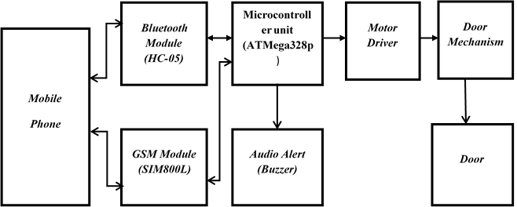
Figure 7: Generalized block diagram of the door security alarm system [5]

The design of the door security alarm system involved calculation of component values and their specifications, stage by stage presentation of all individual modules and their operational principles. The design consists of the following stages/units;
- The Microcontroller
The microcontroller system is designed around the Atmel’s ATMEGA328P microcontroller. ATmega328P microcontroller is the most popular of all AVR controllers as it is used in Arduino boards. It is a high performance, low power controller from Microchip and an 8-bit microcontroller based on AVR RISC architecture. ATmega328P has 32KB internal flash memory, 1KB Electrically Erasable Programmable Read Only Memory (EEPROM) and 2KB Static Random Access Memory (SRAM). It has 28 pins. [45]
Atmega328P has 14 digital input/output (I/O) pins and 6 analog pins, which amount to 20 means of input and output pins. It operates between 1.8-5.5 volts.
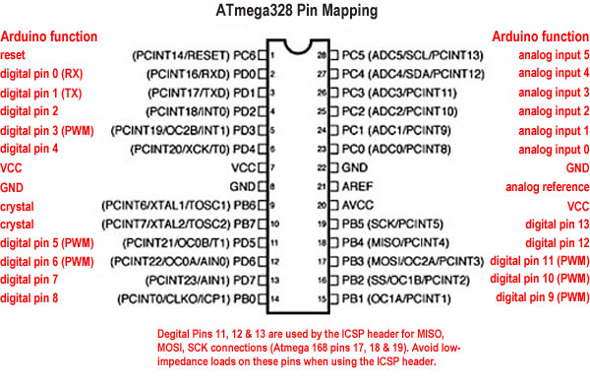
Figure 8: ATmega328 Pin Mapping [45]

- Motor Driver (L298N)
This L298N Motor driver Module is a high-power motor driver module for driving DC and Stepper motors. L298N is a dual H-Bridge motor driver which allows speed and direction control of two DC motors at the same time. It can drive DC motors that have voltages between 5V and 35V with a peak current up to 2A. ENA & ENB pins are speed control pins for Motor A and Motor B respectively while IN1 & IN2 and IN3 & IN4 are direction pins for Motor A and Motor B respectively [47].
This module consists of an L298 Motor Driver IC, 7805 Voltage Regulator, resistors, capacitor, Power LED, 5V jumper in an integrated circuit. The 7805 voltage regulator will only be enabled when the jumper is placed. If the motor supply voltage is less than or equal to 12V, we can enable the 5V regulator and the 5V pin can be used as an output pin to power the microcontroller. But if the supply voltage is greater than 12V, the jumper needs to be disconnected because the voltage can cause damage to the onboard 5V regulator. In this case the 5V pin will be used as input, as it needs to be connected to a 5V power supply in order for the IC to work properly [48].
In order to have a full control over the DC motor, we have to control its speed and rotation direction. This can be achieved by combining these two techniques: Pulse Width Modulation (PWM) and H-Bridge.
PWM DC Motor Control
This is a technique that allows the control of the speed of a DC motor by varying or adjusting the average value of its input voltage. This is done by sending a series of ON-OFF pulses. The average voltage is proportional to the width of the pulses known as Duty Cycle.

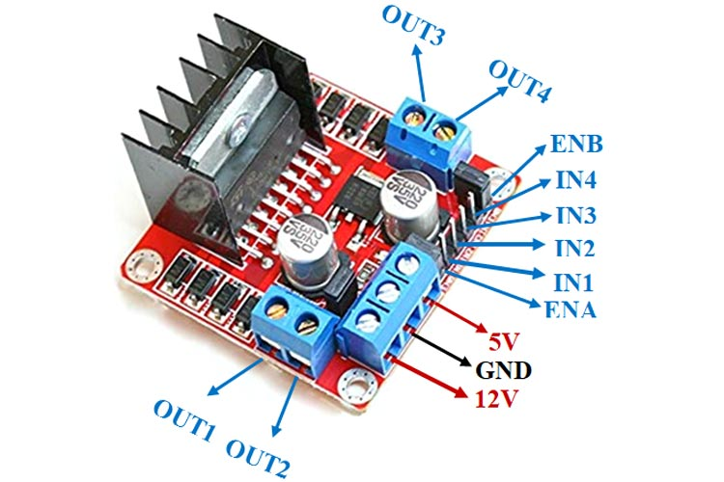
Figure 9: L298N Motor Driver [57]

The average voltage depends on the duty cycle, or the amount of time the signal is ON versus the amount of time the signal is OFF in a single period of time.The higher the duty cycle, the greater the average voltage being applied to the dc motor (High Speed) and the lower the duty cycle, the less the average voltage being applied to the dc motor (Low Speed).
H-Bridge BC Motor Control
The rotating direction of a DC motor can be controlled by changing the direction of the current flow though the motor. An H-Bridge circuit contains four switching elements, transistors or MOSFETS, with the motor at the center forming an H-like arrangement. Activating two particular switches at the same time changes the direction of the current flow. This causes change in the rotation direction of the motor.

- Power Supply Stage
This whole design runs off a 19V/3A AC-DC converter voltage source with 36W (12V/3A) battery backup unit. The power supply stage was designed and implemented to provide the varied required power for each stage that make up this design.
Power Requirement per Stage
GSM Module Stage: a SIM800L GSM module which requires 4V/2A dc was employed for this stage. Hence, a 4V/2A dc power supply was implemented for this stage using LM317, an adjustable output positive voltage regulator.
The output of the LM317 is obtained thus:

Microcontroller Stage: this stage is made up of the microcontroller (ATMega328P), the temperature sensor, the motion sensor and the display stage which all require a 5V/2A dc power source. Hence, a 5V/2A dc power supply was implemented for this stage using LM317, an adjustable output positive voltage regulator.
Power supply stage for the Microcontroller
The output of the LM317 is obtained thus:

Mini Battery backup Stage
This stage seeks to provide an uninterrupted source of power for the design. When mains supply is available, the mini battery backup stage charges the battery and power the design using main supply. In the event of mains failure, with the switch turned on, the design runs on the battery backup.
For the battery charging part, a limiting resistor is used to limit the current delivered to the battery. The value of the resistor is chosen so that the charging current to the cells is not greater than of the cell capacity. For this design, a battery rated at 4500mAh is used; the charging current must not exceed 450mA.
When calculating the value of the resistor, the value of the no-load voltage should be used. This will give the highest charging current. The battery terminal voltage measures 6.9V when fully charged and the no-load output voltage of the power supply is 11.33V.
Hence, the power resistor of value is used in this design.

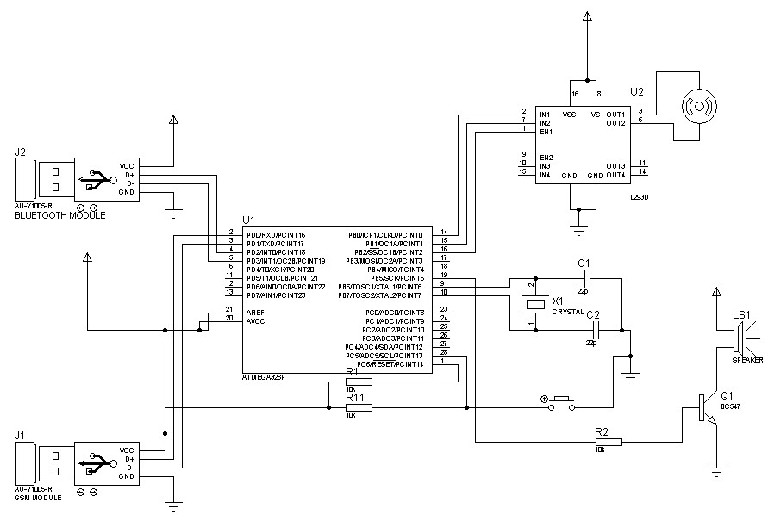
Figure 10: Circuit diagram for the design of the door security alarm system [57]

- CONSTRUCTION, TESTING AND DISCUSSION
Construction
After carrying out all the paper design and analysis, the project was implemented, constructed and tested to ensure its working ability. The construction of this project was done in three different stages.
- The implementation of the whole project on a solder-less experiment board (bread board).
- The soldering of the circuits on printed circuit board.
- The coupling of the entire project to the casing.
i. Implementation
The implementation of this project was done on the breadboard. The power supply was first derived from a bench power supply in the school electronics laboratory to confirm the workability of the circuits before the power supply stage was soldered. The implementation of the project on bread board was successful and it met the desired design aims with each stage performing as designed.
ii. Soldering
The various circuits and stages of this project were soldered in tandem to meet desired workability of the project. The power supply stage was first soldered before the microcontroller, digital display and transistor- relay switching stages were done. The soldering of the project was done on a printed circuit board.
Plate 4.1 below shows the soldering and component arrangement on the printed circuit board.

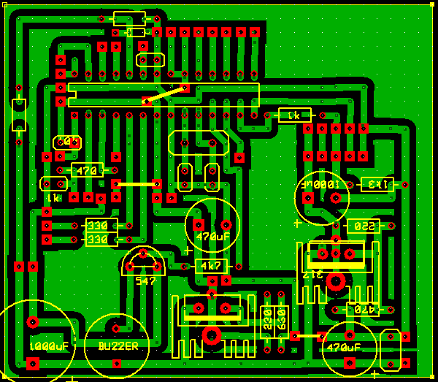
Plate 1: A components layout on printed circuit board. [58]

The printed circuit board has the power supply stage which includes the rectification stage, filtering stage and the voltage regulation stage. It also has the microcontroller stage and the transistor switching stage.

- Casing and Boxing
The third phase of the project construction is the casing of the project. This project was coupled to a plastic casing. The casing material being plastic designed with special perforation and vents and also well labeled to give ecstatic value.

The figures that follow show the pictures of the project: Plate 1-9.

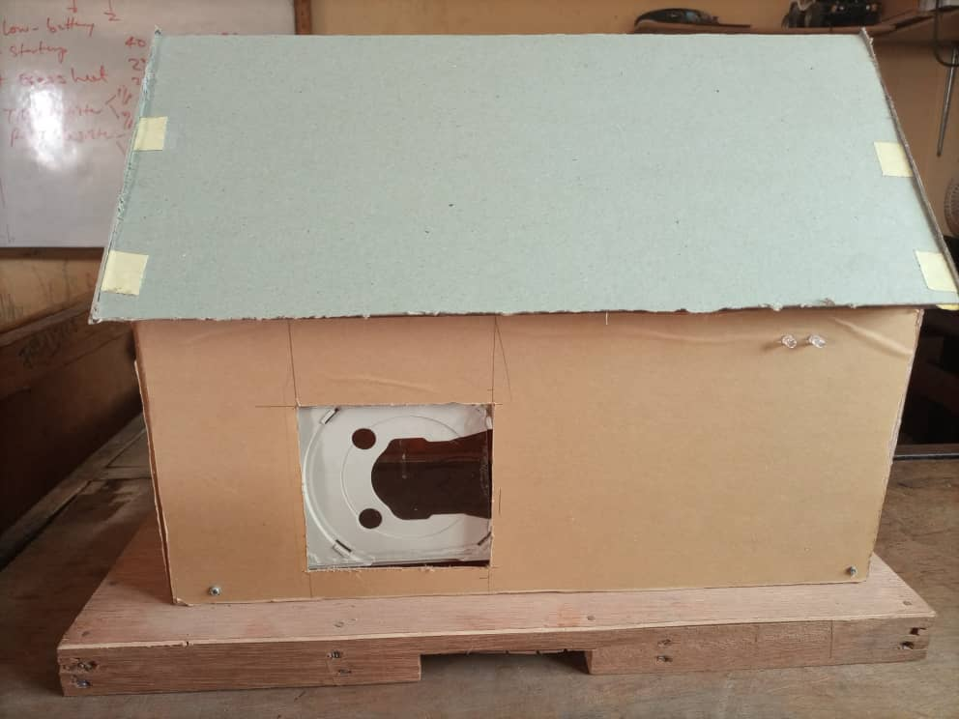
Plate 2: Home Door Security Prototype

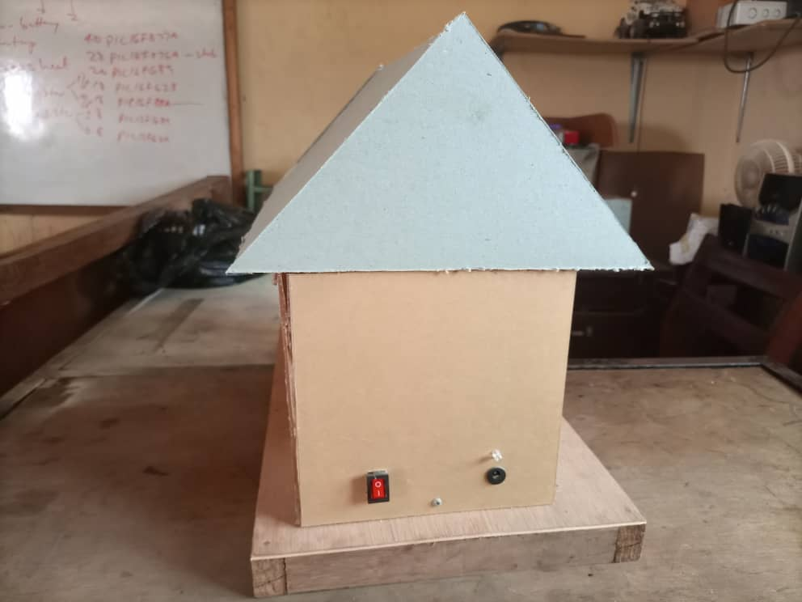
Plate 3: Shows the side view of the project.

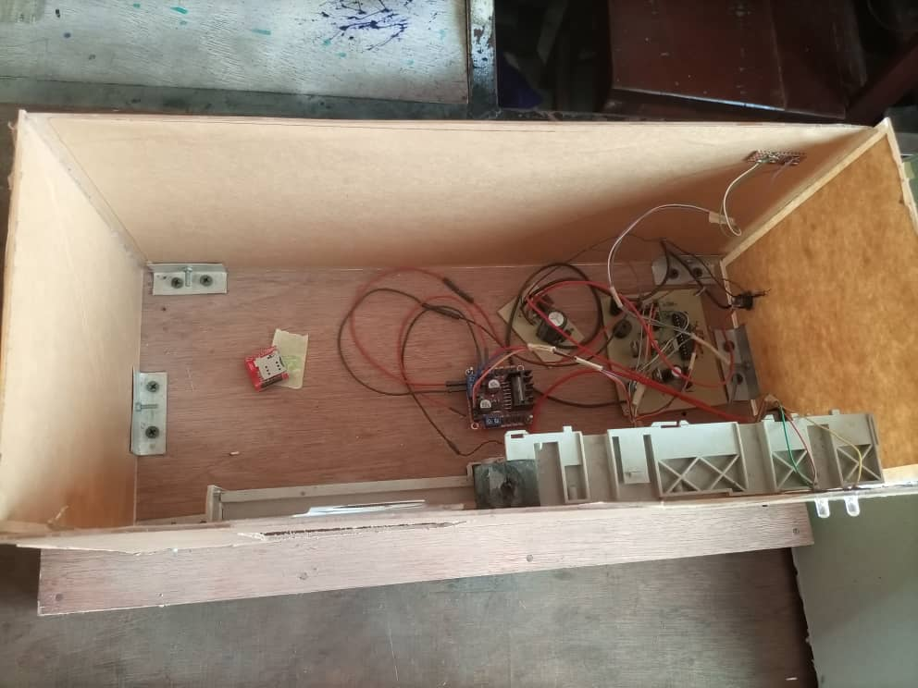
Plate.4: The internal components of the door security project.


Plate 5: Shows interface of the Android application

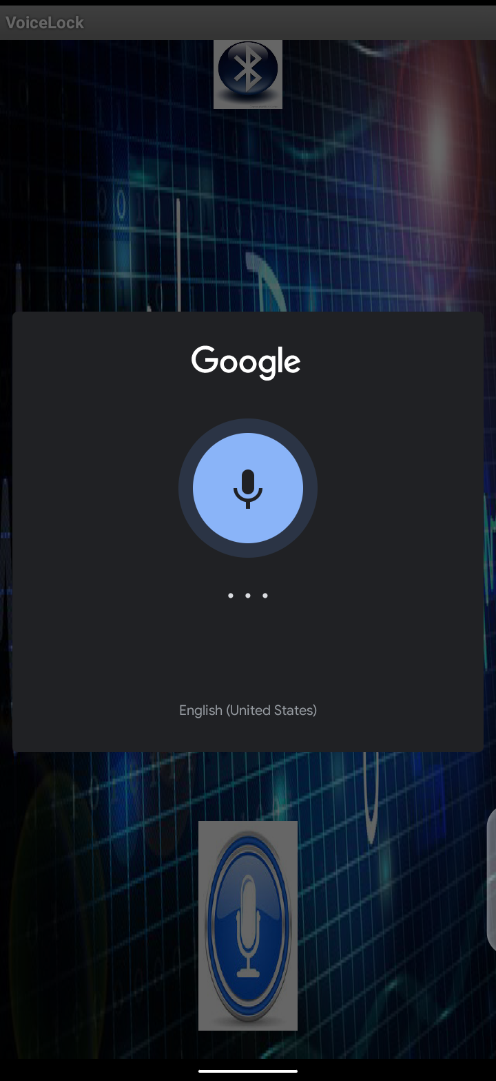
Plate 6: Shows the initialization of the android app using the Google speech recognition.
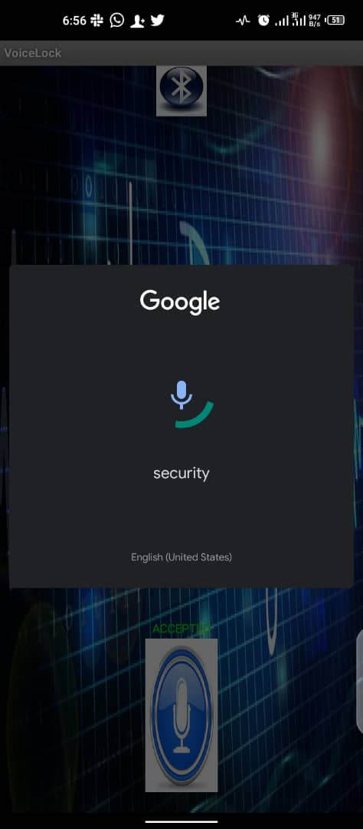
Plate 7: Shows the keyword authentication

Plate 8: Shows the keyword is wrong.

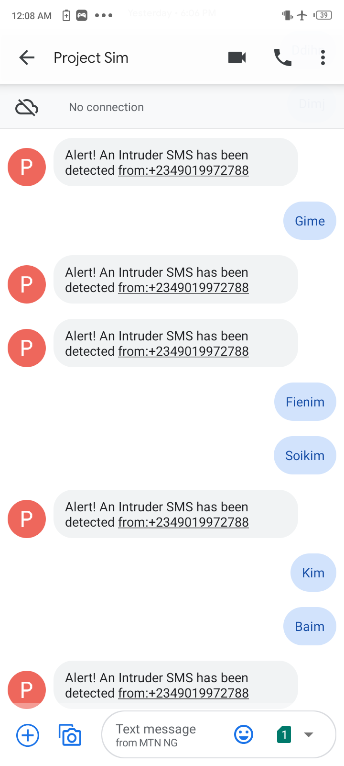
Plate 9: Shows SMS generated message from an unregistered number.

Testing
Stage by stage testing was done according to the block representation on the breadboard, before soldering of circuit commenced on printed circuit board. The process of testing and implementation involved the use of some test and measuring equipment’s stated below.
Bench Power Supply: This was used to supply voltage to the various stages of the circuit during the breadboard test before the power supply in the project was soldered. Also during the soldering of the project the power supply was still used to test various stages before they were finally soldered.
Oscilloscope: The oscilloscope was used to observe the ripples in the power supply waveform and to ensure that all waveforms were correct and their frequencies accurate. The waveform of the oscillation of the crystal oscillator used was monitor to ensure proper oscillation at 16MHz.
Digital Multi-meter: The digital multi-meter basically measures voltage, resistance, continuity, current, frequency, temperature and transistor. The process of implementation of the design on the board required the measurement of parameters like, voltage, continuity, current and resistance values of the components and in some cases frequency measurement. The digital multimeter was used to check the output of the voltage regulators used in this project.

Discussion of Result
- How Voice Command works via the Android Application
The Bluetooth module will serve as a wireless link between the android app and the microcontroller. The android app will have an interface whereby you can speak out the keyword for the door. If the keyword matches with the registered keyword, the android app sends a signal to the Bluetooth module embedded on the device, which also send a signal to the microcontroller to open the door. If the keyword does not match, the device will sound an alarm to alert the property owners by calling them.
- How SMS Verification Works via the GSM Module
The GSM module will serve as a link between the microcontroller and the mobile phone. Through the help of the GSM module, the system will be capable enough to allow the user to instruct the door via SMS from a registered phone number to open the door. On detection of intrusion, the system allows automatic generation of SMS thus alerting the property owners.
The motor driver is to drive the DC Motor. An H-bridge motor driver will be used, so that the motor can go clockwise and anti-clockwise; thereby opening and closing the door.

- Android Application
An android App is a software designed to run on an android device or emulator. The term also refers to an APK file which stands for Android package. This file is a Zip archive containing app code, resources, and Meta information. The Language employed for programming this android app is C++. The Android Application utilizes Google’s open-source speech-to-text voice command for its operation on the door.

Problems Encountered
Like every research and practical engineering work, diverse kinds of problems are often encountered. The problems encountered in this project and how they were solved and maneuvered are listed below.
At the implementation stage of this project, the communication between the controller and the mobile used in this project was found failing. The problem was traced to both items not operating at the same frequency as designed. The oscillator was changed.
Network variation might cause delay in the delivery of the text message. However, the time delay was adjusted to balance the irregularities in the delivery of the message by network providers.

VI. CONCLUSION AND RECOMMENDATIONS
Conclusion
The project which is the design and construction of a GSM home security system was designed considering some factors such as economic application, design economy, availability of components and research materials, efficiency, compatibility and portability and also durability. The performance of the project after test met design specifications. However, the general operation of the project and performance is dependent on the user who is prone to human error such as entering wrong voice control.
Also, the operation is dependent on how well the soldering is done, and the positioning of the components on the printed circuit board. If poor soldering lead is used the circuit might form dry joint early and in that case the project might fail. Also if logic elements are soldered near components that radiate heat, overheating might occur and affect the performance of the entire system. Other factors that might affect performance include transportation, packaging, ventilation, quality of components, handling and usage.
The construction was done in such a way that it makes maintenance and repairs an easy task and affordable for the user should there be any system breakdown. The design of the GSM home security system involved research in both digital and microelectronics.
Recommendations
For the purpose of the future research, the project work can be improved upon. The following areas were highlighted for this purpose.
The whole circuitry can be reduced by making use of integrated circuit with higher scale of integration.
A higher scale integrated circuit can be used so that other means of authentication could be used to cut across to the less privileged in the society (e. g. visually impaired individual). There can be replacement of android app with Raspberry Pi for better voice decoding technique.

- REFERENCE.
[1] Alagu L. R., Anandhajothi,A. & Selvakumari,P. (2015): GSM based authorized access with separate user password door lock and unlock control system, International Journal of Electrical And Electronics Engineers (IJEEE), Vol. 07(01), pp 388-391.
[2] Amit, S. (2013): GSM Based Automated Embedded System for Monitoring and Controlling of Smart Grid, World Academy of Science, Engineering and Technology International Journal of Electrical, Computer, Energetic, Electronic and Communication Engineering Vol. 7(12), pp 1748-1752.
[3] Anubala,B., Rahini,M. &Bavithra,T. (2014): Intelligent Door Locking System.International Journal of Engineering Research and Applications (IJERA) ISSN: 2248-9622 International Conference on Humming Bird,pp 50-53.
[4] Anupriya,S., Elakya,P., Kamatchi,B., Manasa,D. & Rohini,G.(2014): Advanced Entry Level Protection System for Theft.International Journal of Computer Networks and Communications Security, Vol. 2(4), pp 125–128.
[5] Anushri J, Vijay L K & Barkha N (2015): RFID and GSM Based Attendance Monitoring System using door locking/unlocking system and Its Hardware Implementation, Journal of Management Engineering and Information Technology (JMEIT), Vol. 2(3), pp 5-10.
[6] Chen, Pin-Wei; Young, Gregory (December 1984). "Ported coax intrusion detection sensor". IEEETransactions on Antennas and Propagation. 32 (12): 1313–1317.
[7] Chilo, José; Lindblad, Thomas (2008). "Wireless data acquisition system using Bluetooth technology for infrasonic records". Computing. 7 (2): 18–21
[8] Crystalynne,D. C., Jaswinder,S. B., Jocelyn,R. H., Ditche,J. C. A., Melvie,S. D. C.&Jaira,C. I.(2016): Development of Microcontroller-Based Biometric Locker System with Short Message Service” Lecture Notes on Software Engineering, Vol. 4(2), pp 103-106.
[9] Fathima G. DivyaBarathi A, Jaya S & Manjushree R (2015): Intelligent Secure System for Vehicles,International Journal for Scientific Research & Development(IJSRD), Vol. 3(02), pp 438-442,
[10] Geoffrey,C.T. S. (2012): Automatic Access Control System using Student Identification Card Based on RFID Technology, Unpublished Undergraduate Projectof Faculty of Electrical Engineering Universiti Teknologi Malaysia, pp 1-4.
[11] Gowsalya,M., Sangeetha,M., Sri,D.K.K., Divya,N. & Devika,T. (2014): A Novel Approach Automatic Digital Door Opening and Closing Security System, International Journal of Innovative Research in Electrical, Electronic, Instrumentation and Control Engineering, Vol.2(2), pp 991-996.
[12] Gyanendra,K. V. &Pawan,T. (2010): A Digital Security System with Door Lock System Using RFID Technology,international Journal of Computer Applications,Vol. 5(11), pp 6-8.
[13] Hasan,R., Khan,M. M., Ashek,A. &Rumpa, I. J. (2015): Microcontroller Based Home Security System with GSM Technology, Open Journal of Safety Science and Technology, 5, pp 55-62.
[14] Hussaini, H., Adamu,M.Z, Ajagun,A.S., Ijemaru,G. K.&Oresanya,B.O.(2014): Design of a GSM-Based Biometric Access Control System Control Theory and Informatics, Vol.4(8), pp 1-21.
[15] Jaykrishan,P., Joyson,B., Ketan,P., Viral,P., &Ramanuj,G. (2014): Armoured Infrastructure using Multiple Protocols, International Journal of Computer Science and Information Technology Research, Vol. 2(4), pp: 170-174.
[16] Komal,K.M. &Dhiraj,G.A. (2015): Campus Access Management System via RFID, International Journal of Innovative Technology and Exploring Engineering (IJITEE), ISSN: 2278-3075, Vol.4(8), pp 23-27.
[17] Lay,Y. L., Yang,H. J. &Tsai,C. H. (2011): Biometric Locker System, Proceedings of the World Congress on Engineering and Computer Science (WCECS) 2011, San Francisco, USA, Vol. I, pp 1-4.
[18] Lee, Seungmug; Wilson, Harry (2013). "Spatial impact of burglar alarms on the decline of residential burglary" . Security Journal. 26 (2): 180–198. doi:10.1057/sj.2012.8 . ISSN 0955-1662
[19] Lia, K, Alfin,N.S.R, Mada S.W.S. &Edi,M. (2014): Door-Automation System Using Bluetooth-Based Android for Mobile Phone,Asian Research Publishing Network (ARPN) Journal of Engineering and Applied Sciences, Vol. 9(10), pp 1759-1762.
[20] Lynn,A.D & Anne,L.O. (2009): RFID and Application Security, Journal of Research and Practice in Information Technology, Vol. 41(3),pp 209-221.
[21] Manasee,P. & Reddy,S.R.N. (2013): Design and Implementation of Home/Office Automation System based on Wireless Technologies,International Journal of Computer Applications,Vol. 79(6), pp 19-22.
[22] Mohammed Mynuddin Sayidul Morsalin Md. Kamal Hossain Prodip Biswas Design and Implementation of Smart Home Security System International Journal of Modern Embedded System (IJMES) Volume No.-2, Issue No.-6, December, 2014
[23] Mohan,P. & Vinoth,K.M. (2014): Development of Individual Home Security System Using CAN and ZIGBEE Protocol, International Journal of Research in Engineering and Technology,Vol. 03(07), pp581-585.
[24] Nwankwo,P.N., Nsionu,I.I. &Ezeilo,C.J. (2013): Design and Implementation of Microcontroller Based Security Door System (Using Mobile Phone & Computer Set), Journal of Automation and Control Engineering, Vol. 1(1), pp65-69.
[25] Oke,A.O., Adigun,A.A., Falohun,A.S., &Alamu,F.O. (2013): Development of a Programmable Electronic Digital Code lock system, International Journal of Computer and Information Technology, Vol. 02(01), pp 127-131.
[26] Oyebola B. O. Development of HCO6 Bluetooth Based Switching Automation of Domestic Electrical Powered Appliances through an Application Software on Android Phone Platform international Journal of Smart Home Vol. 9, No. 12, 2015
[27] Prasanna,K.R. &Hemalatha,M. (2012): Secure Logistic Management System Using Wireless Technologies, Research Journal of Applied Sciences, Engineering and Technology, Vol. 4(12), pp1785-1789.
[28] Prashantkumar,R., Sagar,V. C., Santosh,S. &Siddharth,N.(2013): Two Wheeler Vehicle Security System, International Journal of Engineering Sciences & Emerging Technologies, Vol. 6(3), pp 324-334.
[29] Priti,K.P.&Zadem,G. N. (2014): Realtime Car Antitheft System with Accident Detection using AVR Microcontroller; A Review, International Journal of Advance Research in Computer Science and Management Studies, Vol. 2(1), pp 509-512.
[30] Raghu,R.G. &SubhramanyaSarma,G. (2013): Locker Opening and Closing System Using RFID, Fingerprint, Password and GSM, International journal of emerging trends & technology in computer science (IJETTCS), Vol. 2(2), pp 142-145.
[31] Ramani,R., Valarmathy,S., Suthanthira,V.N., Selvaraju,S., Thiruppathi,M. & Thangam,R. (2013): Vehicle Tracking and Locking System Based on GSM and GPS, I.J. Intelligent Systems and Application, (IJISA.),pp 86-93.
[32] RS Ragmahale. "A Literature Survey on Smart Home Automation Security." International Journal of Computer Networks and Communications Security 6, no. 1 (2018): 1-8.
[33] Sandeep,S. R., Feroz,M., Sadiya,T. &Mohamed,N. S. (2014): Tracking and Checking Cargo Containers Pilferage Using Electronic Lock, International Journal of Technical Research and Applications,Vol.2(5), PP 113-116.
[34] Sen,M. (2006):Lecture Notes on Intelligent Systems, Department of Aerospace and Mechanical Engineering University of Notre Dame, Notre Dame, IN 46556, U.S.A.
[35] Senthil,K. T. & Praveen,K. (2013): Design of Next Generation Auto Theft Prevention System, International Journal of Scientific Engineering and Technology,Vol.2(3), PP 133-136.
[36] Srinivasan,J.&Krishnamoorthy,M. (2015): Implementation of GSM Technology in Prison Locker System,International Journal of Emerging Technology in Computer Science & Electronics (IJETCSE), Vol. 12(4), pp 15-18.
[37] Supraja,E., Goutham,K. V., Subramanyam,N. &Dasthagiraiah,A. (2014): Enhanced Wireless Security System With Digital code lock using RF &GSM Technology, International Journal of Computational Engineering Research (IJCER), Vol.04(7), pp 80-85.
[38] Tomaso,P. and Luigi,S. (1992): A Project for an Intelligent System: Vision and Learning”, International Journal of Quantum Chemistry, Vol. 42, pp 727-739.
[39] Ushie,J. O., Donatus,E. B. O. &Akaiso,E. (2013): Design and Construction of Door Locking Security System Using GSM.International Journal of Engineering and Computer Science, Vol. 2(7), pp2235-2257.
[40] Agbo, D.O., Madukwe, C. and Odinya, J.O. (2017). Design and Implementation of a Door Locking System Using Android App. International Journal of Scientific and Technology Research, 6(8):198-203.
[41] Kamoru O.I., Olukayode M. F., Shadrack A. E., Akin J. A., Olatunji T. O. “Design and Implementation of Motion Detection Alarm and Security System”. Innovation: International Journal of Applied Research; ISSN: 2347 9272 (Volume-5, Issue-1) , 2017.
[42] Mehmet Cavas and Muhammad Baballe Ahmad “A Review Advancement of Security Alarm System using Internet of Things (Iot)” International Journal of New Computer Architectures and their Applications 9(02):38-49 DOI:10.17781/P002617. November 2019.
[43] Zaid A. Mundher; Khalida Basheer; Safaa Ayad Najeeb; Rami Zuhair. “Build a Real-Time Home Security Alarm System Using a Kinect Sensor” AL-Rafidain Journal of Computer Sciences and Mathematics, 2019, Volume 13, Issue 2, Pages 26-34 10.33899/csmj.2020.163512.
[44] https://nettigo.eu/products/sim800l-gsm-grps-module
[45]https://components101.com/microcontrollers/atmega328p-pinout-features-datasheet
[46]https://www.theengineeringprojects.com/2017/08/int roduction-to-atmega328.html
[47] https://components101.com/modules/l293n-motor-driver-module
[48] https://lastminuteengineers.com/l298n-dc-stepper-driver-arduino-tutorial/
[49]https://howtomechatronics.com/tutorials/arduino/arduino-dc-motor-control-tutorial-l298n-pwm-h-bridge/
[50]https://howtomechatronics.com/tutorials/arduino/arduino-dc-motor-control-tutorial-l298n-pwm-h-bridge/
[51] www.vectorsecurity.com
[52]https://facilitiesmanagementforumforum.co.uk/briefing/tag/access-control
[53]www.historyofkeys.com
[54]en.m.wikipedia.org/wiki/SMS
[55] en.m.wikipedia.org/wiki/biometric_device
[56]https://facilitiesmanagementforumforum.co.uk/briefing/tag/access-control)
[57]https://pin.it/2PJK6nh)
[58] www.pinterest.cpm/pin/435019645250604176
[59] https://www.google.com/search?q=arduino+uno
[60] https://pin.it/4h251mY
[61]https://lastminuteengineers.com/sim800l-gsm-module-arduino-tutorial/

