Hotel Recommendation System Using Hybrid Technique
G Parthasarathy¹ , D Ganesh Gaurav², Dhananjay D³, Chirantan YC⁴, Lavanya GM⁵
^{2,3,4,5}UG Student
^{1,2,3,4,5}School of C&IT, REVA University, Bangalore, India
d.ganeshgaurav@gmail.com²

Abstract—Recommendation systems are software techniques used for suggesting items in an automated fashion to users tailored their preferences. Collaborative filtering may be a set of technologies that predict which items during a set of information a specific customer will like supported the preferences of many people. The multi-user based CF will tend to provide accurate recommendations by considering the user preferences in multiple forms and several methods have been proposed and implemented for improving the accuracy of these systems. However, the problem of multi-user recommendations is still considered an optimization problem with single-user and overall rating . In addition, increasing the accuracy in predicting the appropriate items suggested to the user's preferences is one of the main challenges faced in these systems.
Keywords—Recommendation System, Collaborative Filtering.

1. Introduction
In todays age individuals are getting needy more on web advancements like web. Numerous client focused stages are presently accessible for sharing of data and client connection, for example, Amazon, Flipkart and Myntra. In any case, here comes a run of the mill question, on the off chance that we plan for an outing and visit places you haven't investigated before for a few days, where would it be a good idea for us to live? Picking an appropriate inn for a wonderful outing is significant. By and large, this inquiry compares to suggesting an inn given a specific goal. A recommender framework is an information separating device that breaks down verifiable information to anticipate what clients will be keen on and produce the outcomes. These frameworks regularly show up on the vast majority of the web based business sites which will assist their clients with searching effectively and improve results.When recommender framework experiences another client, foundation information might be lacking. It is difficult to choose whether explicit thing match his/her inclination or not. One potential arrangement is to utilize decent variety methods , to fulfill ones inclination as expansive as could be expected under the circumstances, with the goal that similitude of the proposal result is kept away from. These frameworks for the most part utilize either community oriented separating or substance based sifting or both. At the point when both cooperative and substance based separating is utilized , we call the framework as Half breed Based Proposal.
The goal is to make an inn recommender framework, by making a site. To ensure that clients get exact and solid outcomes and reserve a spot of a lodging while at the same time settling down anyplace on the planet gave they have a web network.

2. related works

One of the renowned application making use of a recommender system is a Hotel Industry. Hotel which suits ones requirements in terms of price, service, quality, location and others is very complex task. Recommendation Systems play a major role by filtering the places which suit the users interests and requirements. Traditional Recommendation system only utilizes user’s rating history. Therefore recommendation for travel is quite difficult, as user hardly rate enough hotels which makes difficult to build user profile.[1]
Due to the increment of various formats of online expressions like reviews, ratings, and recommendation, it’s getting harder to spot users’ preferences toward the products. A large number of reviews can be generated and diffused by online users in travel booking websites. A set of Recommendation Systems (RSs) has emerged to help consumers to filter items based on their preferences. The Collaborative Filtering (CF) based approach is one of the most popular techniques of the RS.[2]

Hotel Recommendation Systems (RecSys) aim to suggest hotels that are potentially to be liked by users. To identify the appropriate hotels, RecSys use various sources of information, such as the historical ratings given by the users and the content of the hotels. RecSys were originally designed for users with insufficient personal experience or with limited knowledge on the hotels.[3]

Recommender systems have been widely used in many online websites to help customers overcome information overload and make their purchase decisions. Commonly used techniques for recommender systems include collaborative filtering, content-based filtering, and knowledge-based recommendation. Content-based filtering assumes that user’s interest can be represented by looking at the content of items they have shown interests, and items whose content descriptions are similar to the target user’s favourite items can be recommended.[4]
Recent rating approaches allow users to specify their review in a higher dimension by providing more fields, which provides a 0-5 star rating input for service ,location and sleep quality and displays it to the user as extra information but does not use this rating for finding recommendations[5].

3. Definition

Recommender System:
A recommender system or a recommendation system may be a sort of information filtering system that quest to predict the "rating" or "preference" a user would give to an item. Recommender systems are a useful alternative to look algorithms since they assist users discover items they could not have found otherwise. This technique recommends the simplest hotels the user's are trying to find and displays the end in the web site.

4.Existing methodology
The existing system is a user login authentication system. Existing system is a combination of two phase. Login phase and sign up phase.
Login Phase:
1. For step-I authentication user is asked for user name and password. The user has to enter a correct username and for password there should be a correct selection login page.
2. For step-II authentication, user login in facebook account. By using facebook id and password.
3. After the successful selection in both the steps the
user is an authorized user to access the particular
system and search hotel by user preferences.
Registration Phase:
1. User enters the username.
2. User enters the Mail Id.
3. User enters the mobile number.
4. User has enter the correct captcha.
5. Systems send the correct password to the user mail id.
6. Registration successful if users select the login phase and enter user name and password

5.Implementation methodology
5.1. Techniques
5.1.1 Content-based Filtering : Content- based filtering utilizes various kinds of models to discover comparability between records so as to deliver suitable suggestion. These strategies make proposal by learning the various models with either measurable examination or AI procedures. Content-based separating strategy despite everything can possibly modify its suggestions inside a brief timeframe.
5.1.2 Collaborative Filtering : Collaborative filtering is an area free forecast strategy for content that can only with significant effort and satisfactorily be portrayed by metadata, for example, motion pictures and music. Community oriented separating strategy mostly works by developing a database, i.e, user-thing framework. This database comprises of inclinations for inns by clients. It at that point matches clients with proper intrigue and inclinations by computing likenesses between their profiles to make suggestions. Suggestions that are produced by Shared sifting can either be forecast or proposal.

5.1.3.MAIL-ID Notification: This module takes care of sending password to eligible user when its account get created and any new user is sign up the web app.

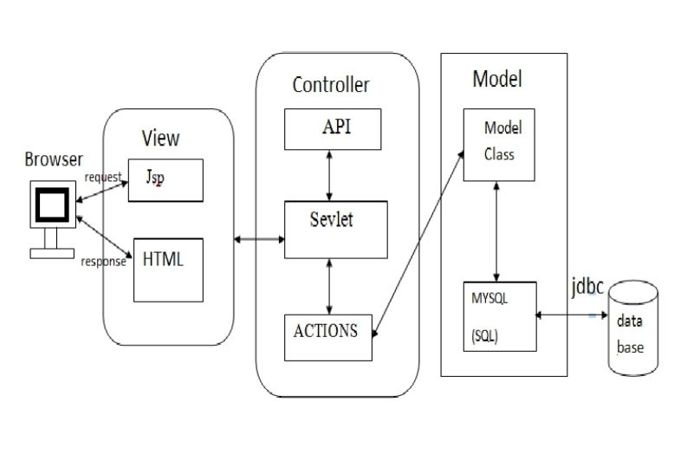

Fig.1 Block Diagram of our work

MODEL - performs major database operation.
MYSQL (sql) – Mysql is used to access and store data.
JDBC – JDBC acts as bridge between Mysql.
CONTROLLER:-
Servlet controller – accepts request and generate response.
API’S – Implement to project specific logic like login, mail, file operation etc.
Action – Action is utilized to Perform various actions like store reviews and get reviews.

5.3. Algorithm-
(i) Start.
(ii) Collect hotel reviews and user reviews.
(iii) Preference factor model.
(iv) Complete user hotel rating matrix.
(v) Improve rating matrix by trip intent.
(vi) Personalized recommendation.
(vii) Stop.

6.Result and discussion

We have used html to create and structure sections, paragraphs, headings, links, and block quotes for web pages and applications. CSS(cascading style sheet) : Cascading style sheets are used to format the layout of Web pages. They can be utilized to define text styles, table sizes, and other aspects of sites that previously could only be defined during a page's HTML. Mysql is used user information and the hotel's data and we use php for multiple purposes which is user authentication connect mqsql database with the webpage and to retrieve and display the stored data, the other programming languages used are JS(JavaScript) which is used to make dynamic web pages and bootstrap for web animations.

7.Conclusion
Our aim was to utilize innovative technology, as a way to boost tourism sector. The possibility of Hotel recommendation will assist client with changing their method of looking through inn by their own preferences.

References

- Khushbu Jalan, Kiran Gawande on Hotel Recommendation System
based on Hybrid Approach to Mitigate Cold-Start-Problem, 2018.

- Priya Naik, Palak V Desai, Supriya Pati on Location Based Place Recommendation using Social Network, 2019.

- Mohammed Mahmudur Rahman, Zulkifly Bin Mohd Zaki, Najwa Hayaati Binti Mohd Alwi, Md Monirul Islam on A hybrid approach to improve recommendation system in E-tourism, 2019.

- Keng-Pei Lin, Chia-Yu Lai, Po-Cheng Chen and San-Yih Hwang, on Personalized Hotel Recommendation Using Text Mining and Mobile Browsing Tracking, 2018.

- V Janani, Lubin Balasubramanian, G Sasikala, G Vidhya, T Kowsalya on a Location Recommendation Based On User Reviews , 2019.

