Efficient computing in Big data warehouse

Prof. Jigna Ashish Patel
Assistant Professor,
Nirma University, Ahmedabad, Gujarat
jignas.patel@nirmauni.ac.in

Dr. Priyanka Sharma
Professor and Head,
Rakshashakti University, Ahmedabad, Gujarat
pspriyanka@yahoo.com

Abstract: With the wide and fast development of tools and technology in big data era, new challenges in development of OLAP and data warehousing took place. To manage big data, distributed environment and Hadoop framework are only the solution. Exponentially increasing data create scalability issue in any model, map reduce programming model resolves that problem. Using these technologies we present series of algorithms combined in our model OOH(Olap on Hadoop) . Measures and dimensions are modeled using DET (Dimension encoding Technique) and DTT (Dimension Traversal Technique), so that Rollup and Drilldown operation can be performed well.

Keywords: data warehouse; OLAP; Hadoop

Introduction
All manuscripts must be in English. These guidelines include complete descriptions of the fonts, spacing, and related information for producing your proceedings manuscripts. Big data is usually pronounced as data with a large volume, variety of data and great velocity. In this digital world everyone generate data, collectively it becomes huge. It is required that we deal with these data in order to provide the factual data analytics. Real time Data warehouse has to be updated to deal with this three V’s, volume, variety and velocity[3] In new paradigm shift we cannot ignore big data for business intelligence. Plenty of innovations has been done on BI and data analytics, only few of them can be feasible if updated or modified for big data. It is not only sufficient if any solution can support only three V’s. Challenges like scalability, work distribution and integration is also that important. Big data technology become very popular amongst every field nowadays. [1] It may use to optimize businesses. Today, almost all type of companies/users who apply the business intelligence utilities are using the raw data generated from company and develop intelligence to take decisions. The huge amount of profile users data are processed and analyzed for advertising.

OLAP and data warehouse are typical fields of data science which have been talked since numerous decades by the Data Warehousing and database research groups. Modern data warehouse deals with every type of data which is controversy with traditional data warehouses. In the context of Big Data research, computing OLAP data cubes over Big Data becomes the most motivating challenges in the research community [5]

Traditional data warehouses process more like SQL type of dataset. It follows the steps like data preprocessing, data modelling, data normalization/denormalization, OLAP operations, and data visualization. [4] Relational OLAP (ROLAP) faces lot of problems in big data era as data volumes get increased exponentially. Scalability, table join operations, unstructured data are major flaws in ROLAP [6]. ROLAP commonly uses star model and snowflake model, which stores dimensions and measures into relational tables, through foreign keys we refer those tables. In this big data era the performance of ROLAP is not accepted only because of costly join operations. Lot of research has been found to increase the performance of ROLAP by various techniques like indexing and hashing. On the other side Multidimensional OLAP (MOLAP) is best suitable solution for big data as it provides fast response time in join operations specifically when the data volume is high. MOLAP system offers robust performance, but it need additional storage to maintain the mappings between dimensions and measures[5]

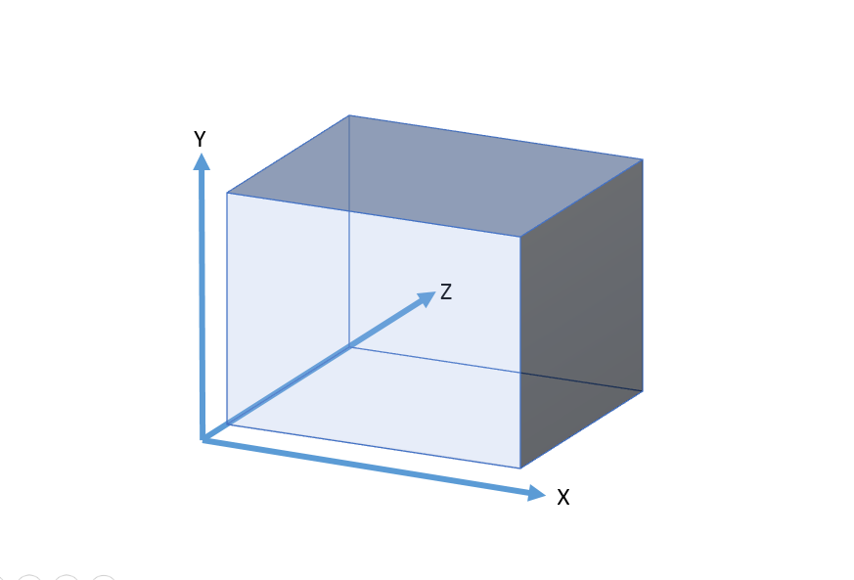
Fig.1 multidimensional data cube

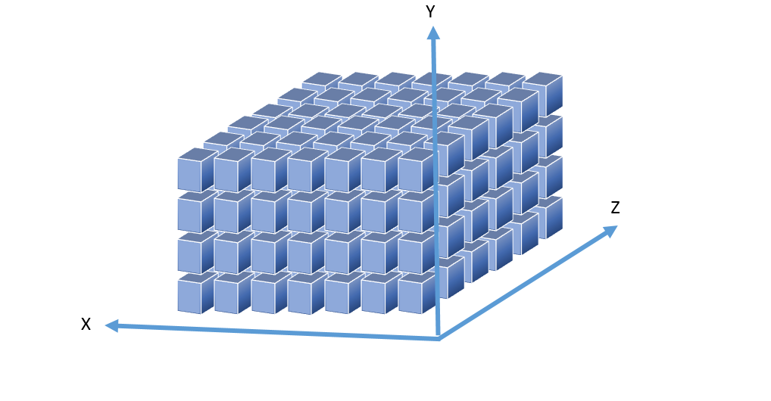Fig. 2 visualization of partitioned cube

As we dealt with multidimensional data model or MOLAP figure-1 shows the multidimensional data cube, chunking is not a new approach in data warehousing. We used chunking method in order to utilize the distributed data environment model. [8] To process the large volume of data parallel processing and distributed working environment is only the solution. We applied horizontal scaling and Hadoop is the best solution to achieve same.
The basic problem of computing OLAP data cubes are varied in the wide variety of data types like classical relational data sets, graph data sets, XML data sets, and social network data sets. Unluckily straight forward solutions won’t helpful for computing OLAP data cube over big data. The reason behind this complexity is increasing data rate and dimensionality of model. When OLAP is merged with data mining, the technique is known as OLAM (Online Analytical Mining) which is very popular for its high performance but not suitable for semi structured or complex data. Lot of solutions (theoretical and practical) are proposed in order to get efficient computation and retrieval of the data from data warehouse and analyzing various heterogeneous data. Scalability and proficiency have been issues in social media from its emergent. Data warehouse is the key phase of the whole procedure from user query to faster response. Data warehouse is always in the research for achieving Business Intelligence (BI). Though massive raw data is generated in every social media website, by using unique and intelligent BI tools and algorithms the target is achieved. Twitter provides tremendous amount of research dataset to work with your proposed algorithm. Since twitter is the most popular microblogging website, here we discussed the OLAP about the tools for twitter data set. The paper is organized in mainly four sections, first we introduced problems in existing environment then series of algorithms and then the implementation and results are discussed.

Problems in existing environment
By looking at the literature survey and related work, at present the lack of effective support for multidimensional data storage model and OLAP analysis needs to be resolved urgently in big data era. At the same time Hadoop is most widely used to resolve scalability issue. To address scalability issue and performance challenges for MOLAP of big data, map reduce programming resolve it using distributed data model. As far as the performance of the OLAP is concerned we use the chunking/ partitioning method to store the big data. To retrieve the particular queried data from the distributed data among number of nodes we process it using indexing method.
Concept of Indexing is used in order to reduce processing unwanted data. Seeking to a particular data field extract wanted data,even though it is in a different chunk and return the pointer to the initial stage.
Series of algorithms are applied in order to escape more storage cost, in OOH we adopted basic and simple data model and advanced algorithms. OOH we adopted basic and simple data model and advanced algorithms. In OOH, we used DET (Dimension encoding Technique) and DTT (Dimension Traversal Technique), DET will solve sparsity problem in multidimensional array as we have used integer encoding technique. Dimension traversal algorithm is used for Roll up and Drill down operation. In following section we mentioned all the algorithms we used for our approach.

Algorithms:
DET (Dimension encoding Technique)
DTT (Dimension Traversal Technique)
DST (Data Storage Technique)

DET (DIMENSION ENCODING TECHNIQUE)
Principally two dimension coding techniques existing for encoding purpose. Binary encoding and integer encoding both have their own pluses and minuses. To avoid sparsity in multidimensional array we can use integer encoding and to gain level wise information directly we can use binary encoding. We used integer encoding technique to avoid sparsity problem.
Let dim_level be a dimension level of dimension dim
Input: dimension dim (“Targeted dimension”)
Process:
For i=0 to |all_level(dim)|
For j=0 to |size(dim)=ᴨi=1all_level|dimi||
Cji belongs to |size(dim)|
Cji=j
End for
End for

DATA STORAGE TECHNIQUE
In order to reduce the storage cost required by OLAP in big data, it is highly essential to serialize the data. In MOLAP storing OLAP requires more space as we need to store multidimensional array and in big data which becomes larger. So in OOH we decided to calculate multidimensional array but we don’t store it. We directly take the data from database server and store in serialized fashion, which will take key and value instead of storing n dimensional data and its value.
In OOH the chunk file and the cells of block are serialized for resolution and deserialize for request-query from user.Chunk file is nothing but the map file given to our mapper stored in Mapfile. Sensibly, cube cells and chunk files are connected with the values of multidimensional array only but actually they are the mapfile of HDFS.
Let X be the multidimensional array with n dimensions as {D1, D2, D3… Dn} Co-ordinates of array values are denoted as {P1, P2, P3… Pn}, Serialization
Index(X) = [D1 + [D2 * P1] + [D3 * P2] + ……. + [Dn*Pn-1] ]… … … … eq-1

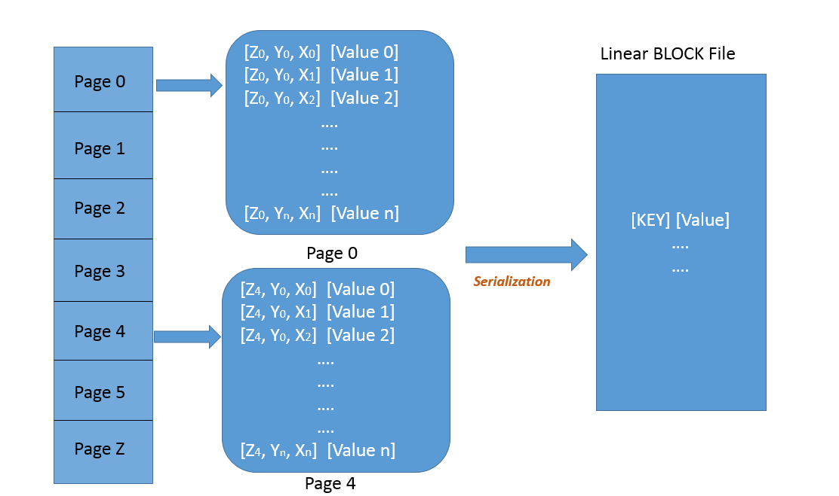

Fig 3: Serialization
As shown in figure-3 the paging concept is clearly visible instead of storing the value using multidimensional array we can serialize it in a key.
Similarly deserialize concept is applicable when we process the query.in order to find out the coordinates we can reversely apply the same concept.
Deserialization
T1 = index
P1 = T1 % D1 T2 = T1 / P1
P2 = T2 % D2 T3 = T2 / P2
.
..
…
Pn = Tn % Dn
Dimension traversal Technique
In OOH, to perform roll up and drill down, we devised a technique called DTT. The hierarchy tree is generated from all dimension values. In hierarchy tree the dimension level is treated as node of a tree.
Drill down and roll up are the operations performed with the logic if value of C i+1 is given which will go till C I called as drill down operation. Similarly, roll up operation if Ci to C i+1. Following operations are to be applied in order to achieve.

Value (Ci) = [(order (Ci) + |Ln| X (order (Ci-1) + |Ln-1| X . . . . X (order (C1) + 0] ----- eq (2)
From above equation we can derive the relation of Value (Ci) and (order (Ci)
finali = Value (Ci)
(order (Ci) = finali % |Li|
finali-1 = finali / |Li|
(order (C1) = final1 % |Li| ----------eq(3)
Based on equation (3) and (4) Value (Ci-1) to Value (C1) can be calculated. if Value (Ci) is given, then the order of whole Path can be found. Eg. At day level Value (23)= 32.
<19901 , 22 , 23> is found. value(23)

Implementations and Results
As there is no impact of domain or an application on our model, we can choose any database to test our model. We downloaded the oceanography data of around 10GB to validate our model. Mainly the oceanography database includes three dimension, Time, Area and Depth. For all these dimensions we have number of levels too. Following figure shows number of levels for each dimension.
(i)Time = {<Year>, <Season>, <Month>, <Day>, <Slot>};
(ii)Area A = {<1°>, <1/2°>, <1/4°>, <1/8°>, <1/16°>, <1/32°>, <1/64°>};
(iii)Depth D= {<100m>, <50m>, <10m>}.
We implemented our Algorithms on Hadoop. For the implementation in OOH we used map reduce framework. Input-formatter, mapper, reducer and output formatter are the key four parts in which the map reduce job executes. The query quadruple is submitted by the client and verified by the job node to avoid process failures.
As and when query quadruple is submitted by client and verified for deterministic failures. Input formatter takes data from chunk selection algorithm as chunk list. Every coordinates of cell are deserialize and checked by query conditions. If coordinates match the query condition, serialized coordinate of the cell are pass to mapper. Firstly the chunk selection file is detected by job node. It will scan all the cells and chunks, parallelly coordinates of the cell are deserialize and checked by the query conditions. If the coordinates find match with the serialized coordinate of the cell then it is pass to mapper. Mapper work with the < key, value > pairs.
In existing models , Input formatter deserialize every key and value and check by condition, mapper used to prcess a single element and wait till next element, which is simple a brute force technique. OOH, input formatter runs DST and DET algorithm which reads the block of data so it process the array of element and mapper will process the bunch of data and meanwhile input formatter is ready with the next block of data and hence, it is much faster than existing models.

Plot 1: comparison of cube on X direction

Plot 2: comparison of cube on Y direction

Conclusion and future enhancements
In this paper we exemplify the model to execute OLAP operations in Hadoop environment successfully. We elaborated the scalability and data loading issue perfectly with the solution. Evaluation and comparison of OOH is shown with existing models (HaOLAP), existing approach for Hadoop based OLAP operations. Future enhancement at this stage is to involve more operations like pivot or rotate with OLAP and to abide with the current model.

VI. References
- J. Song, C. Guo, Z. Wang, Y. Zhang, G. Yu, and J.-M. Pierson, “HaoLap: A Hadoop based OLAP system for big data,” Journal of Systems and Software, vol. 102, pp. 167–181, Apr. 2015.
- J. A. Patel and P. Sharma, “Big data for better health planning,” in Advances in Engineering and Technology Research (ICAETR), 2014 International Conference on, 2014, pp. 1–5.
- Blanco, I. García-Rodríguez de Guzmán, E. Fernández-Medina, and J. Trujillo, “An architecture for automatically developing secure OLAP applications from models,” Information and Software Technology, vol. 59, pp. 1–16, Mar. 2015
- D.-H. Shin and M. J. Choi, “Ecological views of big data: Perspectives and issues,” Telematics and Informatics, vol. 32, no. 2, pp. 311–320, May 2015.
- J. Patel and P. Sharma, “Decision Support System in Diabetes Disease with Providing Health Care Services,” 2015.
- Avita katal,Mohammad wazid,R H Goudar," Big data:, Issues,Challenges,Tools and Good practices" IEEE 2013.
- J. Li, L. Meng, F. Z. Wang, W. Zhang, and Y. Cai, “A Map-Reduce-enabled SOLAP cube for large-scale remotely sensed data aggregation,” Computers & Geosciences, vol. 70, pp. 110–119, Sep. 2014.
- A. Cuzzocrea, L. Bellatreche, and I.-Y. Song, “Data warehousing and OLAP over big data: current challenges and future research directions,” in Proceedings of the sixteenth international workshop on Data warehousing and OLAP, 2013, pp. 67–70.
- Xin Cheng,Chungjin Hu,Yang Li, Wei Lin, Haolei Zuo., "Data Evolution of virtual dataspace for managing the big data lifecycle ",IEEE 2013
- S. Mansmann, N. Ur Rehman, A. Weiler, and M. H. Scholl, “Discovering OLAP dimensions in semi-structured data,” Information Systems, vol. 44, pp. 120–133, Aug. 2014.
- Big data survey research brief ,2013, www.sas.com/resources/whitepaper/wp_58466.pdf

